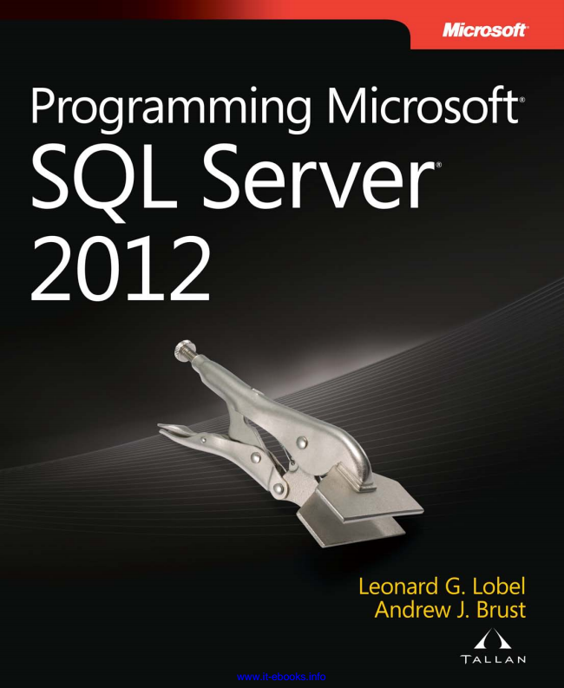

www.it-ebooks.info

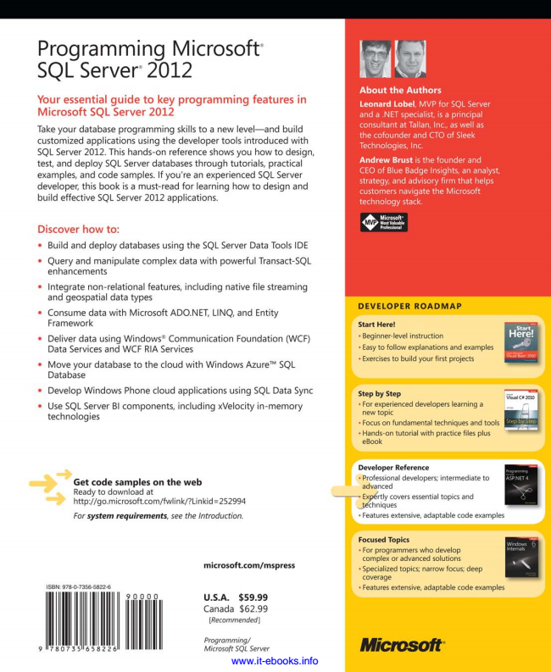

www.it-ebooks.info

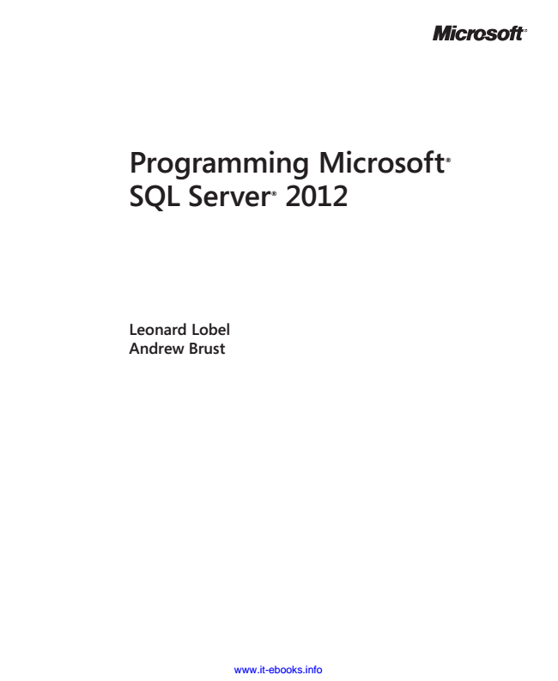

**Programming Microsoft**

**® SQL Server**

**®**

**2012**

**Leonard Lobel Andrew Brust**

www.it-ebooks.info

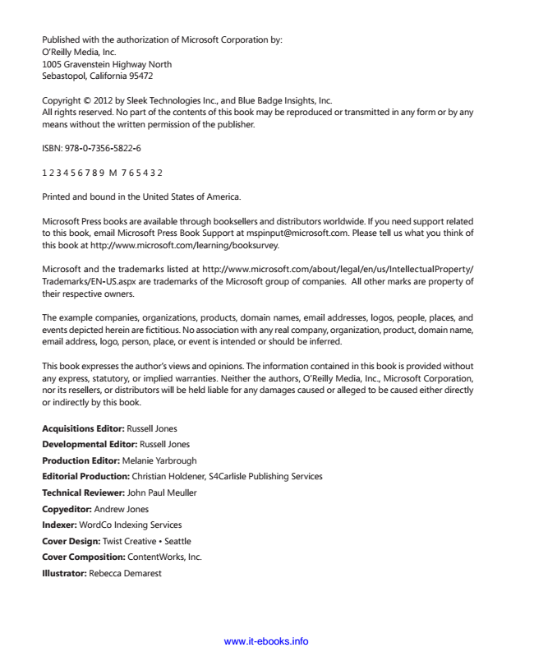

Published with the authorization of Microsoft Corporation by: O’Reilly Media, Inc. 1005 Gravenstein Highway North Sebastopol, California 95472

Copyright © 2012 by Sleek Technologies Inc., and Blue Badge Insights, Inc. All rights reserved. No part of the contents of this book may be reproduced or transmitted in any form or by any means without the written permission of the publisher.

ISBN: 978-0-7356-5822-6

1 2 3 4 5 6 7 8 9 M 7 6 5 4 3 2

Printed and bound in the United States of America.

Microsoft Press books are available through booksellers and distributors worldwide. If you need support related to this book, email Microsoft Press Book Support at mspinput@microsoft.com. Please tell us what you think of this book at http://www.microsoft.com/learning/booksurvey.

Microsoft and the trademarks listed at http://www.microsoft.com/about/legal/en/us/IntellectualProperty/ Trademarks/EN-US.aspx are trademarks of the Microsoft group of companies. All other marks are property of their respective owners.

The example companies, organizations, products, domain names, email addresses, logos, people, places, and events depicted herein are fictitious. No association with any real company, organization, product, domain name, email address, logo, person, place, or event is intended or should be inferred.

This book expresses the author’s views and opinions. The information contained in this book is provided without any express, statutory, or implied warranties. Neither the authors, O’Reilly Media, Inc., Microsoft Corporation, nor its resellers, or distributors will be held liable for any damages caused or alleged to be caused either directly or indirectly by this book.

**Acquisitions Editor: Russell Jones**

**Developmental Editor: Russell Jones**

**Production Editor: Melanie Yarbrough**

Editorial Production: Christian Holdener, S4Carlisle Publishing Services

**Technical Reviewer: John Paul Meuller**

Copyeditor: Andrew Jones

Indexer: WordCo Indexing Services

Cover Design: Twist Creative • Seattle

Cover Composition: ContentWorks, Inc.

Illustrator: Rebecca Demarest

www.it-ebooks.info

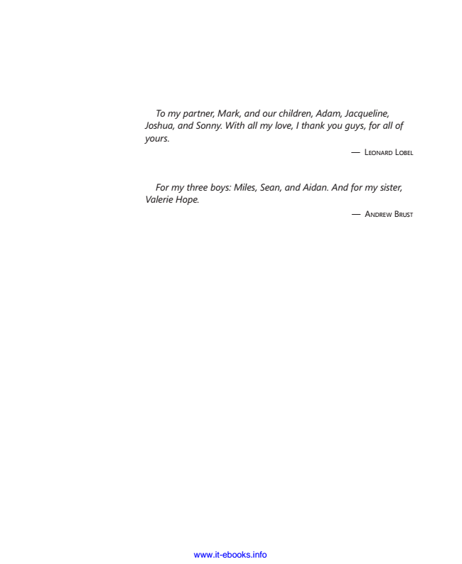

*To my partner, Mark, and our children, Adam, Jacqueline, Joshua, and Sonny. With all my love, I thank you guys, for all of yours.*

— L

EONARD

L

OBEL

*For my three boys: Miles, Sean, and Aidan. And for my sister, Valerie Hope.*

— A

NDREW

B

RUST

www.it-ebooks.info



www.it-ebooks.info

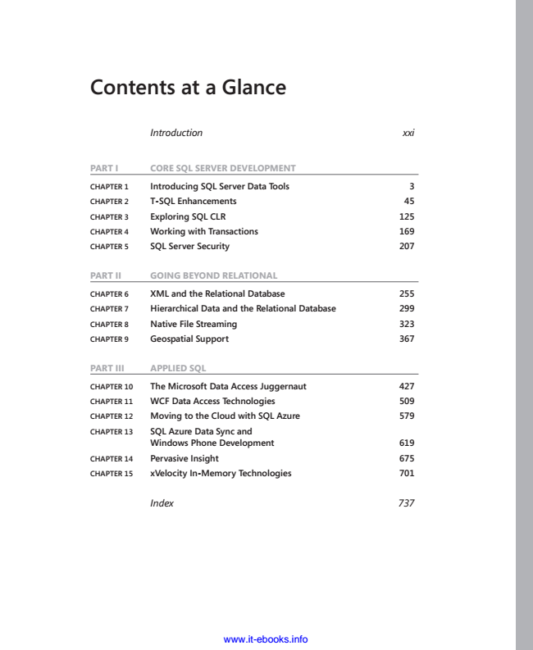

**Contents at a Glance**

*Introduction xxi*

**PART I CoRE SQL SERvER DEvELoPmEnT**

**ChAPter 1 Introducing SQL Server Data tools 3**

**ChAPter 2 t-SQL enhancements 45**

**ChAPter 3 exploring SQL CLr 125**

**ChAPter 4 Working with transactions 169**

**ChAPter 5 SQL Server Security 207**

**PART II GoInG BEyonD RELATIonAL**

**ChAPter 6 XML and the relational Database 255**

**ChAPter 7 hierarchical Data and the relational Database 299**

**ChAPter 8 Native File Streaming 323**

**ChAPter 9 Geospatial Support 367**

**PART III APPLIED SQL**

**ChAPter 10 the Microsoft Data Access Juggernaut 427**

**ChAPter 11 WCF Data Access technologies 509**

**ChAPter 12 Moving to the Cloud with SQL Azure 579**

**ChAPter 13 SQL Azure Data Sync and**

**Windows Phone Development 619**

**ChAPter 14 Pervasive Insight 675**

**ChAPter 15 xVelocity In-Memory technologies 701**

*Index 737*

www.it-ebooks.info



www.it-ebooks.info

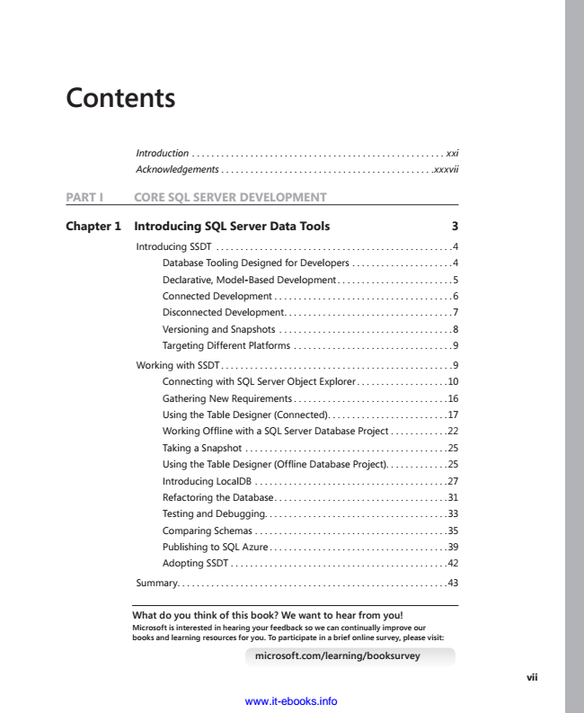

**Contents**

*Introduction . . . . . . . . . . . . . . . . . . . . . . . . . . . . . . . . . . . . . . . . . . . . . . . . . . . . xxi*

*Acknowledgements . . . . . . . . . . . . . . . . . . . . . . . . . . . . . . . . . . . . . . . . . . . .xxxvii*

**PART I CoRE SQL SERvER DEvELoPmEnT**

**Chapter 1 Introducing SQL Server Data Tools 3**

Introducing SSDT . . . . . . . . . . . . . . . . . . . . . . . . . . . . . . . . . . . . . . . . . . . . . . . . .4

Database Tooling Designed for Developers . . . . . . . . . . . . . . . . . . . . .4 Declarative, Model-Based Development . . . . . . . . . . . . . . . . . . . . . . . .5

Connected Development . . . . . . . . . . . . . . . . . . . . . . . . . . . . . . . . . . . . .6 Disconnected Development . . . . . . . . . . . . . . . . . . . . . . . . . . . . . . . . . . .7

Versioning and Snapshots . . . . . . . . . . . . . . . . . . . . . . . . . . . . . . . . . . . .8 Targeting Different Platforms . . . . . . . . . . . . . . . . . . . . . . . . . . . . . . . . .9

Working with SSDT . . . . . . . . . . . . . . . . . . . . . . . . . . . . . . . . . . . . . . . . . . . . . . . .9

Connecting with SQL Server Object Explorer . . . . . . . . . . . . . . . . . . .10 Gathering New Requirements . . . . . . . . . . . . . . . . . . . . . . . . . . . . . . . .16

Using the Table Designer (Connected) . . . . . . . . . . . . . . . . . . . . . . . . .17 Working Offline with a SQL Server Database Project . . . . . . . . . . . .22

Taking a Snapshot . . . . . . . . . . . . . . . . . . . . . . . . . . . . . . . . . . . . . . . . . .25 Using the Table Designer (Offline Database Project) . . . . . . . . . . . . .25

Introducing LocalDB . . . . . . . . . . . . . . . . . . . . . . . . . . . . . . . . . . . . . . . .27

Refactoring the Database . . . . . . . . . . . . . . . . . . . . . . . . . . . . . . . . . . . .31 Testing and Debugging. . . . . . . . . . . . . . . . . . . . . . . . . . . . . . . . . . . . . .33

Comparing Schemas . . . . . . . . . . . . . . . . . . . . . . . . . . . . . . . . . . . . . . . .35 Publishing to SQL Azure . . . . . . . . . . . . . . . . . . . . . . . . . . . . . . . . . . . . .39

Adopting SSDT . . . . . . . . . . . . . . . . . . . . . . . . . . . . . . . . . . . . . . . . . . . . .42

Summary. . . . . . . . . . . . . . . . . . . . . . . . . . . . . . . . . . . . . . . . . . . . . . . . . . . . . . . .43

**What do you think of this book? We want to hear from you! Microsoft is interested in hearing your feedback so we can continually improve our books and learning resources for you. to participate in a brief online survey, please visit:**

**microsoft.com/learning/booksurvey**

www.it-ebooks.info

**vii**

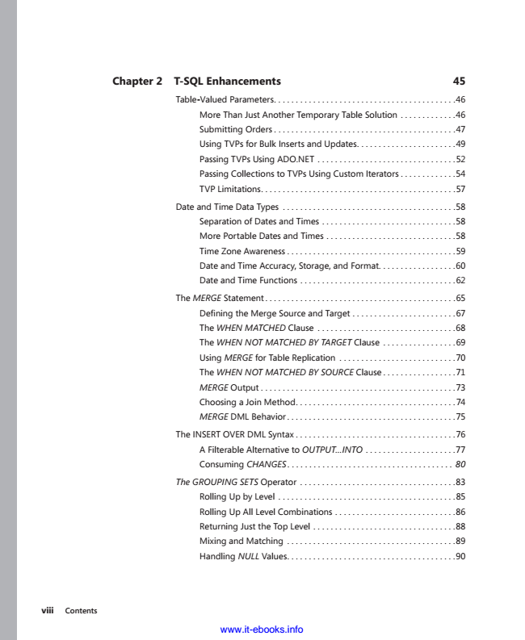

**viii Contents**

**Chapter 2 T-SQL Enhancements 45**

Table-Valued Parameters . . . . . . . . . . . . . . . . . . . . . . . . . . . . . . . . . . . . . . . . . .46

More Than Just Another Temporary Table Solution . . . . . . . . . . . . .46 Submitting Orders . . . . . . . . . . . . . . . . . . . . . . . . . . . . . . . . . . . . . . . . . .47

Using TVPs for Bulk Inserts and Updates . . . . . . . . . . . . . . . . . . . . . . .49 Passing TVPs Using ADO.NET . . . . . . . . . . . . . . . . . . . . . . . . . . . . . . . .52

Passing Collections to TVPs Using Custom Iterators . . . . . . . . . . . . .54 TVP Limitations . . . . . . . . . . . . . . . . . . . . . . . . . . . . . . . . . . . . . . . . . . . . .57

Date and Time Data Types . . . . . . . . . . . . . . . . . . . . . . . . . . . . . . . . . . . . . . . .58

Separation of Dates and Times . . . . . . . . . . . . . . . . . . . . . . . . . . . . . . .58 More Portable Dates and Times . . . . . . . . . . . . . . . . . . . . . . . . . . . . . .58

Time Zone Awareness . . . . . . . . . . . . . . . . . . . . . . . . . . . . . . . . . . . . . . .59 Date and Time Accuracy, Storage, and Format . . . . . . . . . . . . . . . . . .60

Date and Time Functions . . . . . . . . . . . . . . . . . . . . . . . . . . . . . . . . . . . .62

The MERGE Statement . . . . . . . . . . . . . . . . . . . . . . . . . . . . . . . . . . . . . . . . . . . .65 Defining the Merge Source and Target . . . . . . . . . . . . . . . . . . . . . . . .67

The WHEN MATCHED Clause . . . . . . . . . . . . . . . . . . . . . . . . . . . . . . . .68 The WHEN NOT MATCHED BY TARGET Clause . . . . . . . . . . . . . . . . .69

Using MERGE for Table Replication . . . . . . . . . . . . . . . . . . . . . . . . . . .70 The WHEN NOT MATCHED BY SOURCE Clause . . . . . . . . . . . . . . . . .71

MERGE Output . . . . . . . . . . . . . . . . . . . . . . . . . . . . . . . . . . . . . . . . . . . . .73 Choosing a Join Method . . . . . . . . . . . . . . . . . . . . . . . . . . . . . . . . . . . . .74

MERGE DML Behavior . . . . . . . . . . . . . . . . . . . . . . . . . . . . . . . . . . . . . . .75

The INSERT OVER DML Syntax . . . . . . . . . . . . . . . . . . . . . . . . . . . . . . . . . . . . .76 A Filterable Alternative to OUTPUT...INTO . . . . . . . . . . . . . . . . . . . . .77

*Consuming CHANGES . . . . . . . . . . . . . . . . . . . . . . . . . . . . . . . . . . . . . . 80*

The GROUPING SETS Operator . . . . . . . . . . . . . . . . . . . . . . . . . . . . . . . . . . . .83 Rolling Up by Level . . . . . . . . . . . . . . . . . . . . . . . . . . . . . . . . . . . . . . . . .85

Rolling Up All Level Combinations . . . . . . . . . . . . . . . . . . . . . . . . . . . .86 Returning Just the Top Level . . . . . . . . . . . . . . . . . . . . . . . . . . . . . . . . .88

Mixing and Matching . . . . . . . . . . . . . . . . . . . . . . . . . . . . . . . . . . . . . . .89 Handling NULL Values . . . . . . . . . . . . . . . . . . . . . . . . . . . . . . . . . . . . . . .90

www.it-ebooks.info